islam fadl – Wessam Muhammed

university of science and technology Zewailcity  Sheikh Zayed

project cassini–spring 2017

**Introduction:**

Deep space communication mission is considered one of the most challenging engineering problems. Of course this case results from working in a very harsh environment like space, in addition as an engineering design problem, there are various parameters to be optimized and keep track on.

In order to optimize for the parameters into consideration, limitations for this mission must be defined. Firstly, the high bit rate (HBR) link is 100 kbps used for images and scientific data. The maximum size of high gain antenna (HGA) is 4 meters in diameter. Secondly, considering the low bit rate link (LBR), which is used for telemetry, it should be 10’s of bits with a beamwidth of at least 55 degrees. The bit error rate (BER) should not exceed 10^-5 for either link. Finally, 50 watt (17 dBW) are allocated for the transmitter.

Using these pre-defined parameters, we will focus on three bands, the S-Band (2.2-2.3 GHz), X-Bnad (8.4-8.5 GHz) and the K-Bnad (31.8-32.3 GHz).

Since the downlink is the weakest link in the chain, we will focus the calculations on it.

**Methods:**

In our work we performed the calculations twice, analytically and using STK.

***Analytical method:***

In the analytical method we used the equations we studied seeking the bit error rate desired goal where (BER) is less than 10^-5. So the (BER) is considered a starting point for us. In order to do that, we approached the design problem from the root.

From the frequencies provided above in the introduction section, we can find the wavelengths used, then we substitute it to find the transmitting antenna gain for each band:

S-Band: G = 32.3 dB

X-Band: G = 47.6 dB

K-Band: G = 59 dB

Some assumptions were made beforehand to ensure consistent results using different bands. The noise temperature = 40 K, Rain loss = -4 dB, Beam loss = -3Db, Link margain = -5dB, in addition the transmitting power is assumed to be 50 watts = 17dB.

Based on these assumptions, the Noise for the High bit rate (HBR) and the low bit rate (LBR) is as follows:

N for (HBR) = -154 dB

N for (LBR) = -184 dB

Using the Q-function table(1) we managed to identify the transmitted power through solving multiple equations. Lstly other parameters were found and listed in the table below.

In case of low gain antenna taking the noise into respect

Without noise ( clean air – high efficacy equipment)

|  |  |  |  |
| --- | --- | --- | --- |
|  | lbr -ka | Lbr – x | Lbr-s |
| Pt | 17 | 17 | 17 |
| Rain | -4 | -4 | -4 |
| Beam loss | -3 | -3 | -3 |
| Link margin | -5 | -5 | -5 |
| Gt | 8.6 | 8.6 | 8.6 |
| Gr | 80.23 | 68.53 | 57.178 |
| Path loss | -305.85 | -293.8 | -282.8 |
| noise | 140.43 | 140.43 | 145.2 |
| Cdma gain | 50 | 50 | 54.7712 |
| 0.5fec | 6 | 6 | 6 |
|  |  |  |  |
| x | -14.85 | -14.5 | -5.3 |
| Ber | large | large | large |
|  |  |  |  |
|  |  |  |  |
|  |  |  |  |

|  |  |  |  |
| --- | --- | --- | --- |
| x | -5.85 | -5.5 | 3.6 |
| ber | large |  | 2.8*10^-2 |
|  |  |  |  |

***Systems Toolkit Method:***

The optimization of the link budget design focused on minimizing the bit error rate by varying multiple design aspect as shown in the STK file attached with this report. Following is the link budget report for the high bit rate signal used for imagery and scientific data, and the low bit rate signal used for telemetry purpose.

* Using the High Gain Antenna (HGA), a solid bit error rate of 10^(-6) was applicable for the K-Band

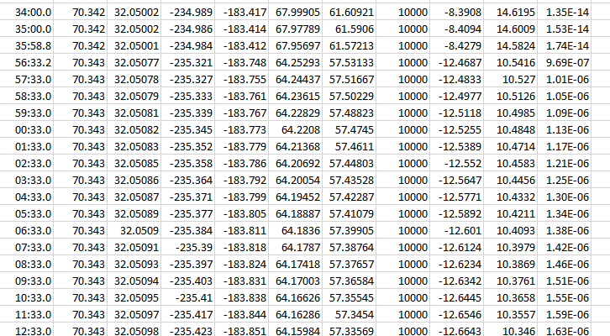

* Using the High Gain Antenna (HGA), a solid bit error rate of 10^(-7) was applicable for the X-Band

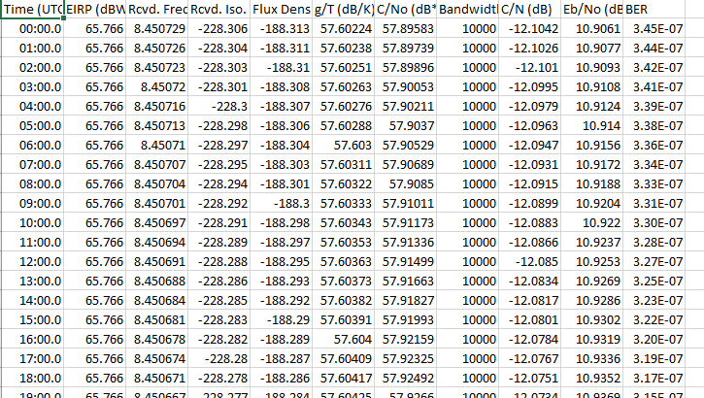

* Using the High Gain Antenna (HGA), a modest bit error rate of 10^(-2) was applicable for the S-Band

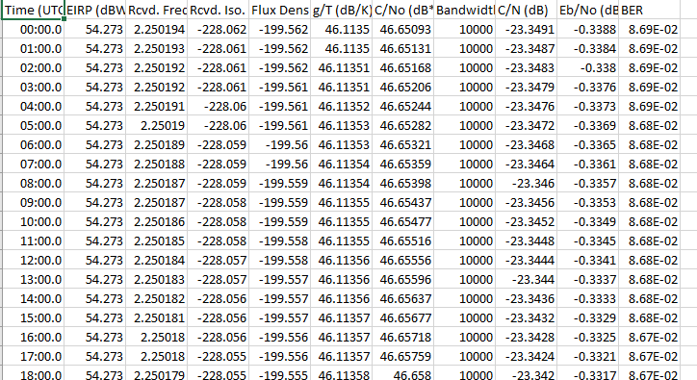

* Using the Low Gain Antenna (LGA), a bit error rate of 10^(-3) was applicable for the K-Band

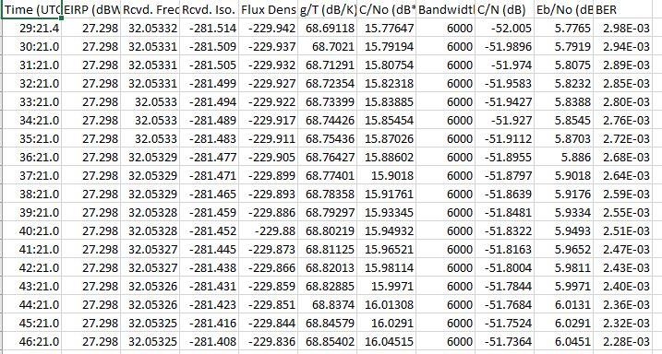

* Using the Low Gain Antenna (LGA), a solid bit error rate of 10^(-5) was applicable for the X-Band

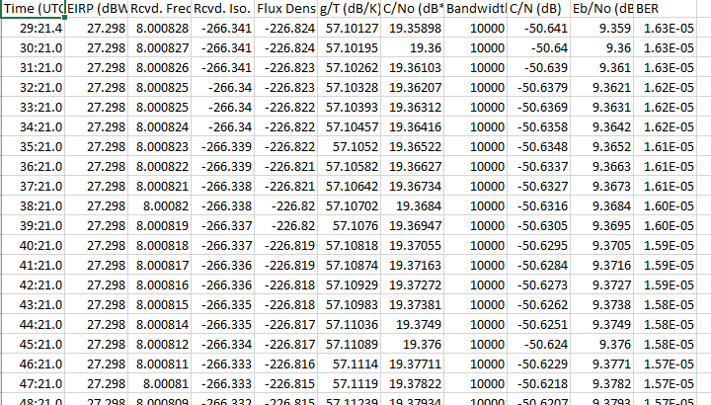

* Using the Low Gain Antenna (LGA), a solid bit error rate of 10^(-6) was applicable for the S-Band

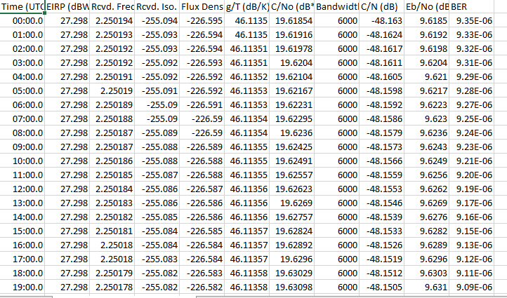

**Conclusion:**

Regarding the high bit rate signal, it is recommended to choose either the K-Band or the X-band for this task as it meets the (BER) criteria. On the other hand, the S-Band and the X-Band outperform the K-Band for receiving the telemetry data with a minimal (BER).

**References:**

1. Q-function table, P.33, Lecture 7, Eltarras, A.
2. DESCANSO Design and Performance Summary Series, Article 3, Cassini Orbiter/Huygens Probe, Telecommunications